**LAB MANUAL**

**DevOps using Jenkins**

**Installation of Jenkins.war file**

**Click the link to see installation steps**

[**https://www.jenkins.io/doc/book/installing/war-file/**](https://www.jenkins.io/doc/book/installing/war-file/)

**To open Jenkins again give**

**java -jar jenkins.war in command prompt**

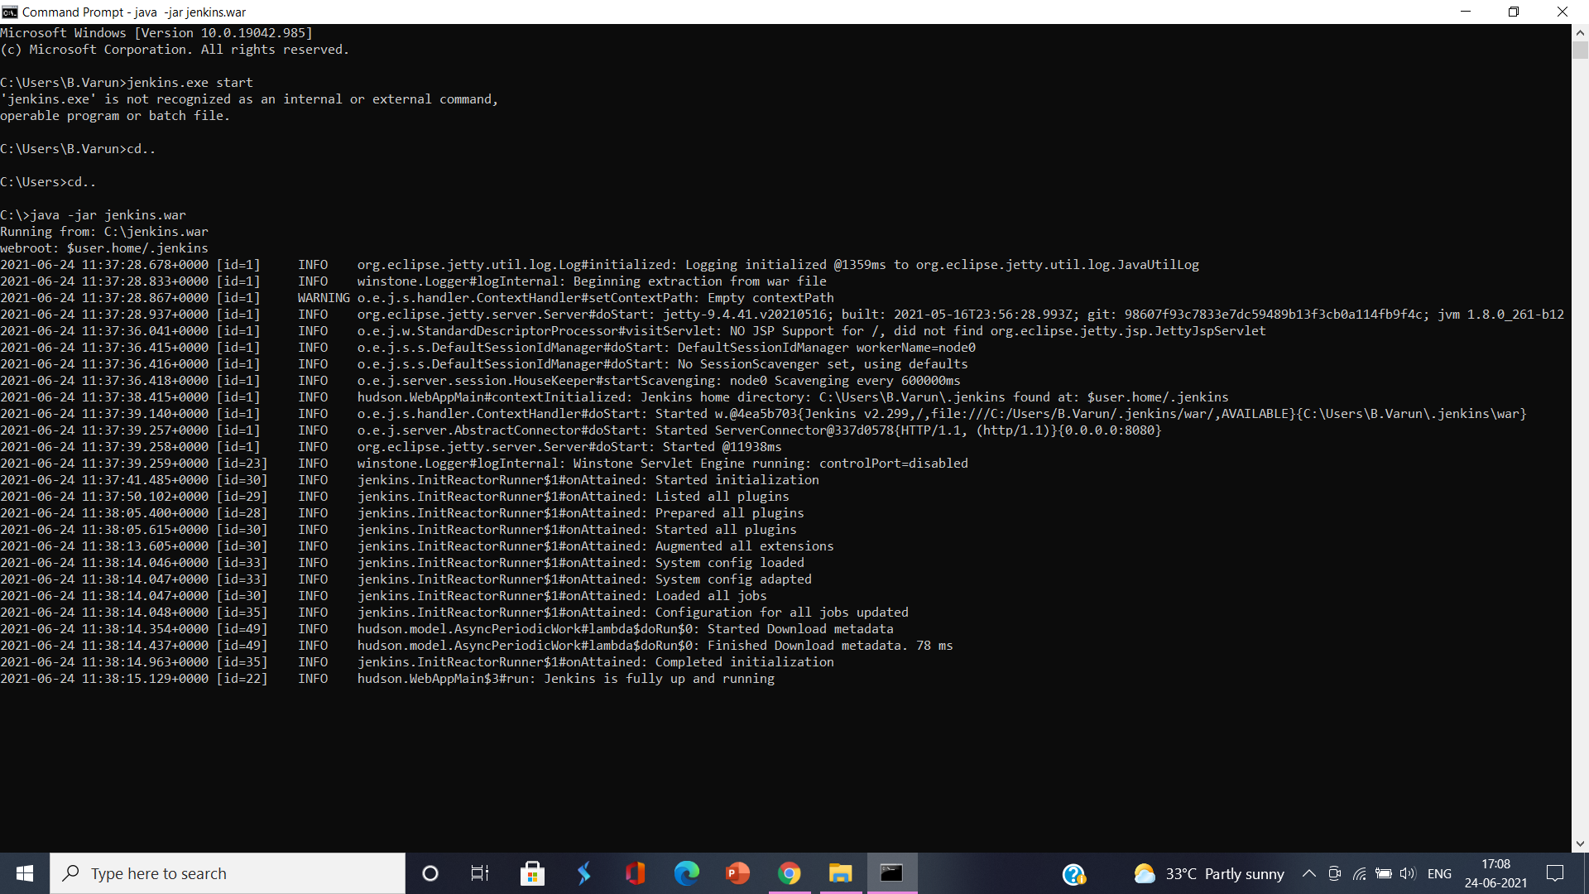

**1.Create a simple job using Jenkins**

Aim of the program

To create a job using Jenkins

Algorithm:

Step 1: Open jenkin's click on new item from the dashboard

Step 2: Give a name to the item and click on freestyle project then click on OK button

Step 3: Create a job by giving a name to and in Build Project section select execute Windows Batch Command

Step 4 enter the code

**echo ‘ First Job Created’**

Step 5 click on dashboard

Step 6: click on build option

Step 7: once build is over click on console output to check whether the build is success or failure

**2.Create multiple jobs and trigger one after another using Jenkins**

Aim of the program

To create multiple jobs and Trigger one job after another job

Algorithm:

step 1 Open Jenkins click on new item from the dashboard

step 2 Give a name to the item choose freestyle project and then click ok button

Step 3 : Create two more item and name them for each job enter the script

Step 4:Set the options under Build Tab as Execute Windows Batch Command and Give the code as

**echo ‘ First Job : Triggered at : %date% : %time%’**

Step 5:In the Post Build Action Tab select Build Other Projects - >sec_job. Continue the same for Sec_Job also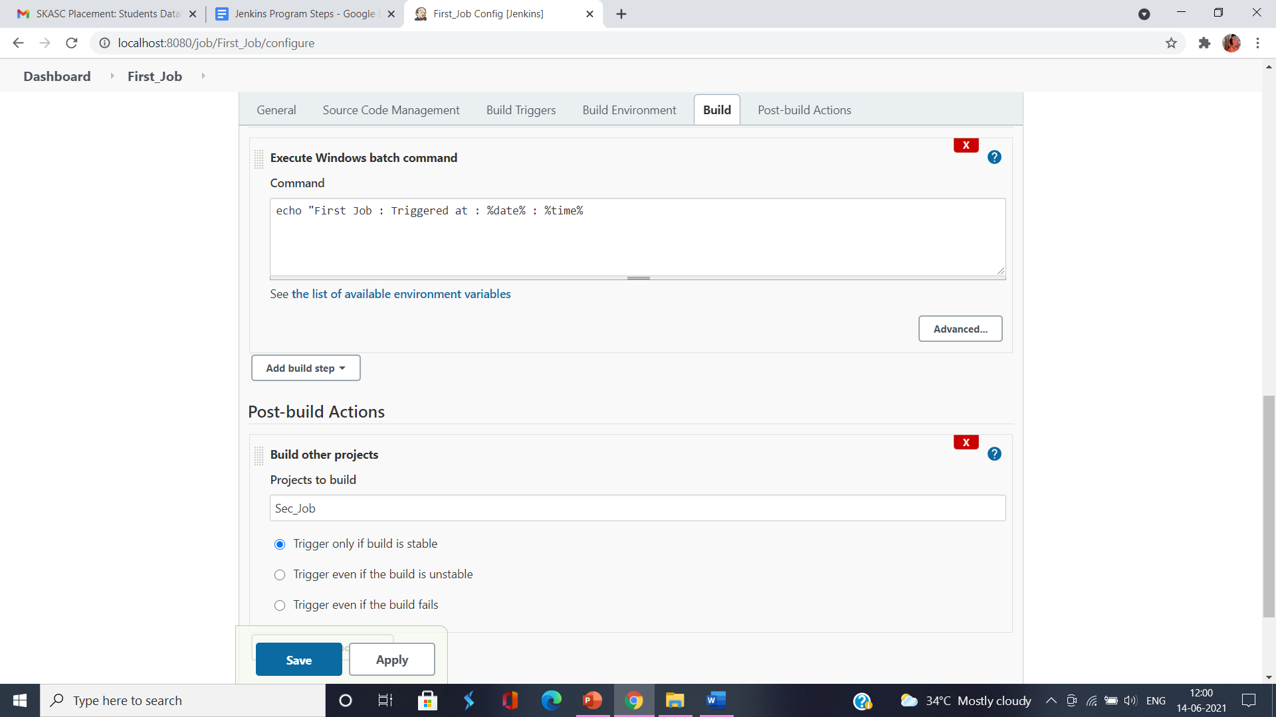

**3.Create multiple jobs and visualize the jobs using Delivery Pipeline Plugin**

Aim of the program

To create multiple jobs and visualize the jobs using Delivery Pipeline Plugin

Algorithm:

step 1 Open Jenkins click on new item from the dashboard

step 2 Give a name to the item-> choose freestyle project and then click ok button

Step 3 : Create two more item and name them

Step 4:Set the options under Build Tab as Execute Windows Batch Command and Give the code as

**echo ‘ First Job : Triggered at : %date% : %time%’**

Step 5:In the Post Build Action Tab select Build Other Projects - >sec_job. Continue the same for Sec_Job also

Step 6:To visualize the the jobs install Delivery Pipeline Plugin

Step 7: In the pipeline section give a name for the pipeline and choose the initial job.

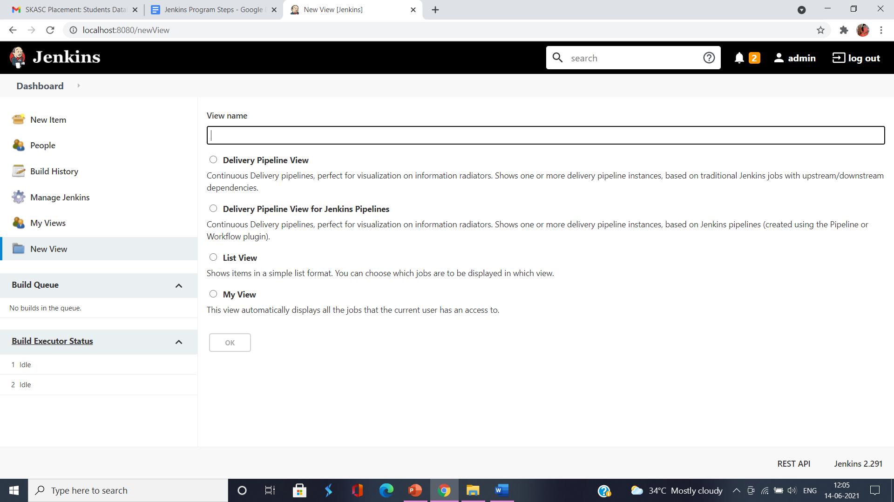

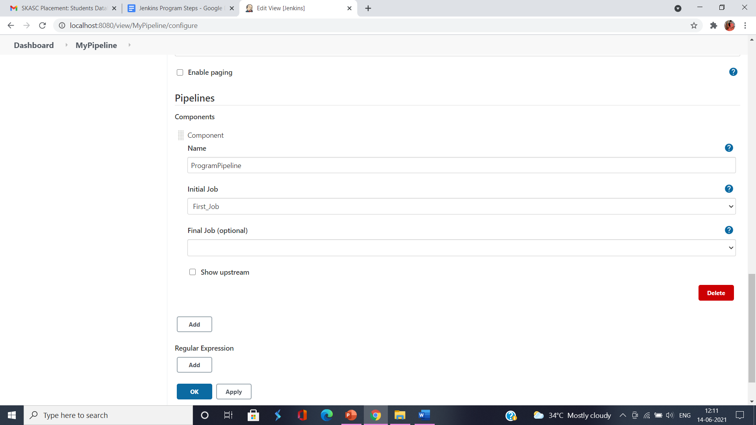

**4.Create a simple pipeline script to build and echo any statement of your own**

Aim of the Program:

To create a pipeline script to build and echo any statement

Algorithm:

Step 1 : Open Jenkins click on new item from the dashboard

Step 2 : Give a name to the item-> choose pipeline project and then click ok button

Step 3 : Click on Pipeline Tab and enter the pipeline code

pipeline{

agent any

stages{

stage('hello'){

steps{

echo 'Welcome to Jenkins Pipeline';

}

}

}

}

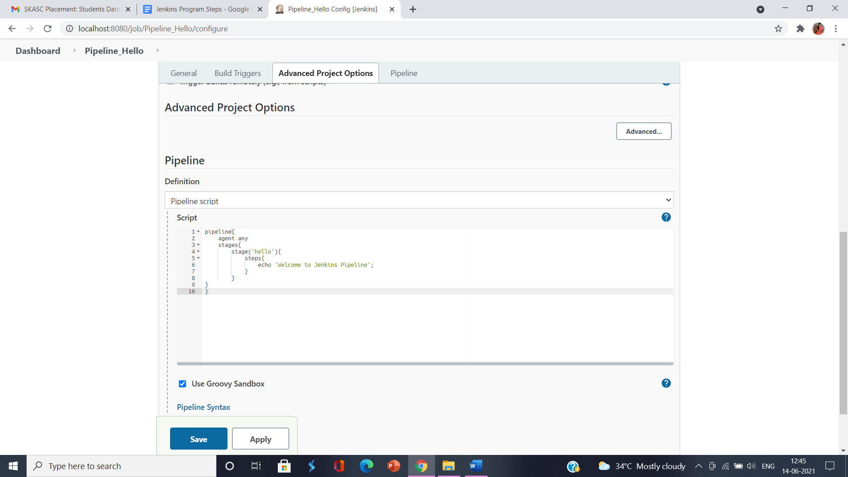

Step 4: Click on save button and build the pipeline->check Console Output for success of the pipeline build.

**5. Create a Scripted Pipeline with different stage including Compile, Test, QualityCheck and Deploy**

Aim of the Program:

To create a pipeline script with different stages Compile, Test, QualityCheck and Deploy

Algorithm:

Step 1 : Open Jenkins click on new item from the dashboard

Step 2 : Give a name to the item-> choose pipeline project and then click ok button

Step 3 : Click on Pipeline Tab and enter the pipeline code with different stages

pipeline {

agent any

stages{

stage('Compile'){

steps{

echo 'Compiled Successfully';

}

}

stage('Junit'){

steps{

echo 'Junit Passed Successfully';

}

}

stage('Quality_Gate'){

steps{

echo 'Quality Passed Successfully';

}

}

stage('Deploy'){

steps{

echo 'Deploy Passed Successfully';

}

}

}

post{

always{

echo ' This will always run'

}

success{

echo ' This will run success'

}

failure{

echo ' There is a failure'

}

unstable{

echo ' This will run when run is unstable'

}

changed{

echo ' This will always run when stage of Pipeline has changed'

}

}

}

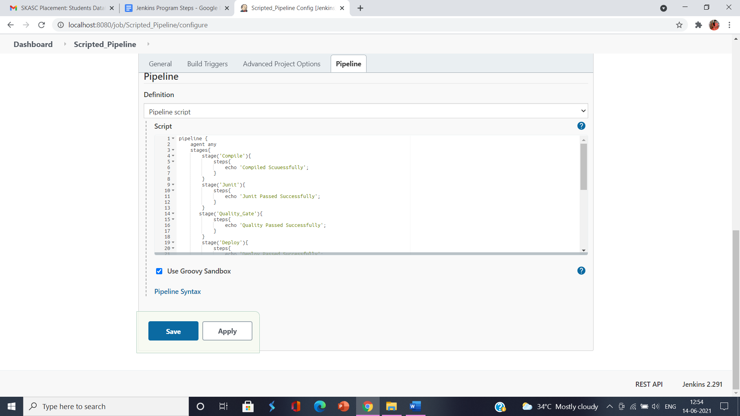

Step 4: Click on save button and build the pipeline->check Console Output for success of the pipeline build.

**6. Create a Scripted Pipeline code to Clone Git repo on Jenkins using Declarative Pipelines**

Aim of the Program:

To create a pipeline script to clone Git Repo on Jenkins using Declarative Pipelines

Algorithm:

Step 1 : Open Jenkins click on new item from the dashboard

Step 2 : Give a name to the item-> choose pipeline project and then click ok button

Step 3 : Click on Pipeline Tab and enter the pipeline code with different stages

pipeline{

agent any

stages{

stage('Git'){

steps{

git 'https://github.com/simplilearn-github/Pipeline_Script.git'

}

}

}

}

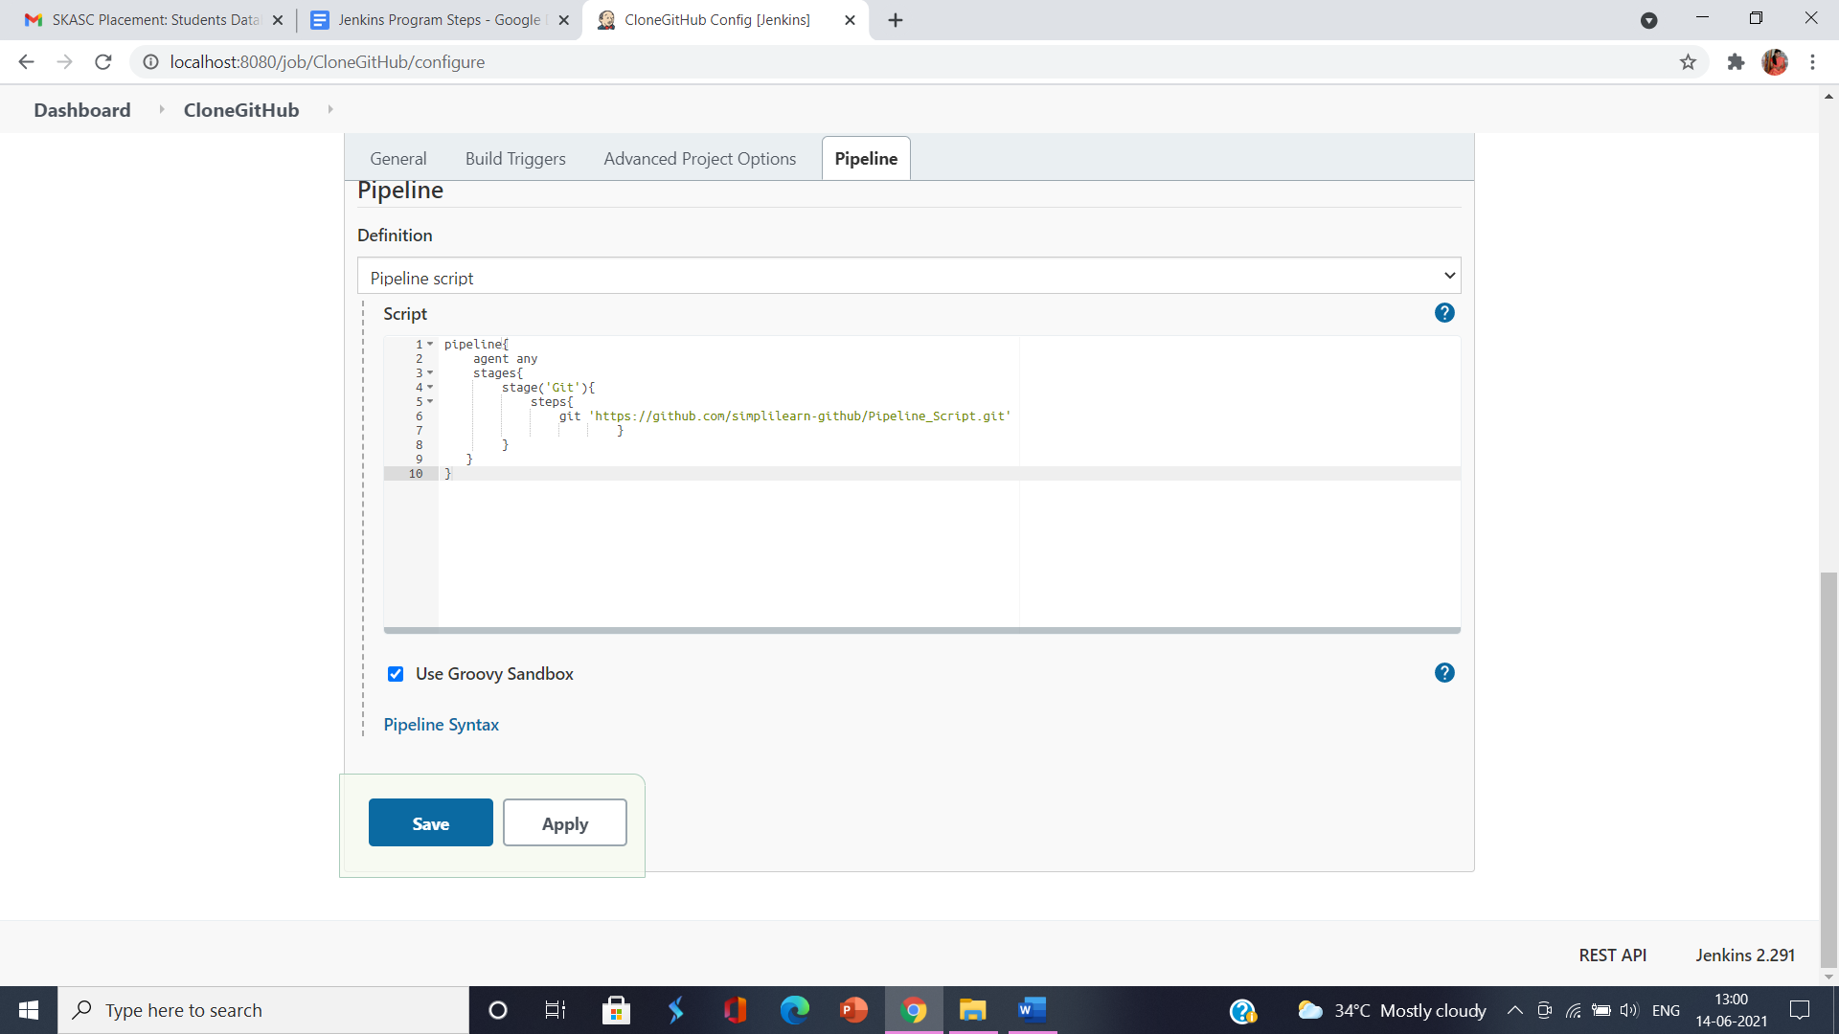

Step 4:Click on save button and build the pipeline->check Console Output for success of the pipeline build

**7.Create a new build job with a public Git Repository**

Aim of the Program:

To create a new build job with a public Git Repository

Algorithm:

Step 1 : Open Jenkins click on new item from the dashboard

Step 2 : Give a name to the item-> choose Freestyle project and then click ok button

Step 3 : From Source Code Management Tab select Git option and enter Git URL

<https://github.com/kishancs2020/TicketBookingServiceJunitTesting.git>

Copy the URL from GitHub

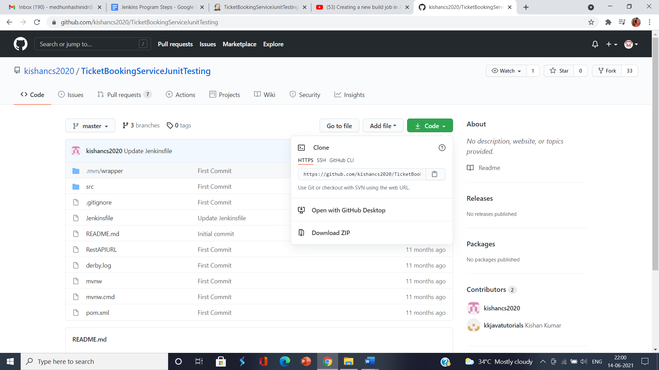

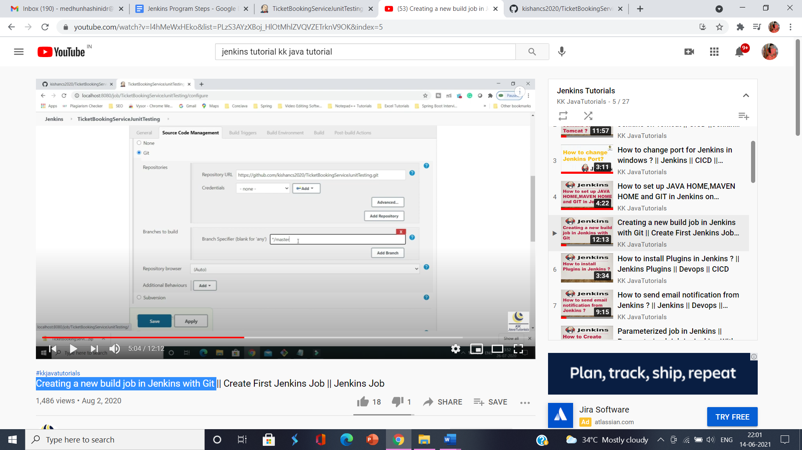

Step 4: Click on Build Tab and select Invoke Top-Level Maven Targets. Enter Maven Version and Goals as clean package.Then Select advanced setting to enter POM as pom.xml from the git url file

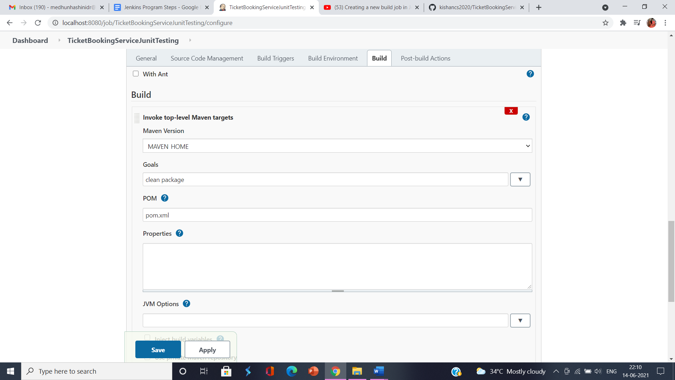

Step 5:Click on Apply---->Save.Build the project and check Console Output for successful executable jar file creation in the drive

**8.Create a job and build periodically by scheduling at a given time**

Aim of the Program:

To create a new build job and schedule at a given time

Algorithm:

Step 1: Use the existing [TicketBookingServiceJunitTesting](https://github.com/kishancs2020/TicketBookingServiceJunitTesting.git) job

Step 2: Click on Configure and select Build Triggers Tab

Step 3: Under Build Trigger Tab select Build Periodically option

Step 4: Set up MINUTE HOUR DOM MONTH DOW like H/2 * * * *. Every 2 minutes

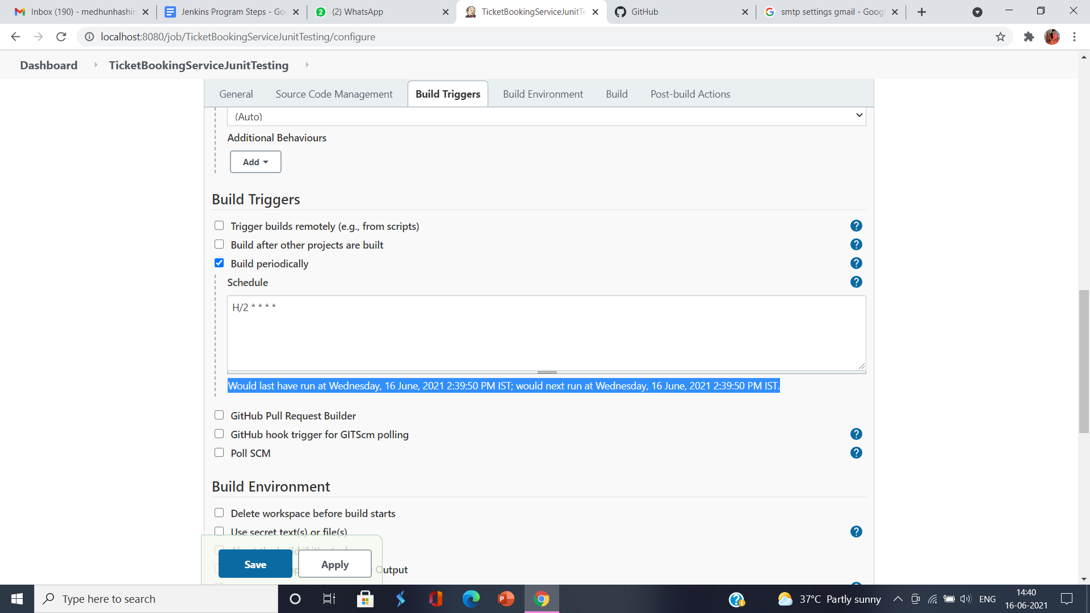

Step 5:Apply and Save the setting to check for the auto build that happens every 2 mins.

**9.Create a job and configure email notifications in Jenkins via Gmail SMTP to send email after the build executed**

Aim of the Program:

To create a job and configure email notifications in Jenkins via Gmail SMTP to send email after the build executed

Algorithm:

Step 1 : Google Search for gmail SMTP settings and find the settings needed to Configure in jenkins

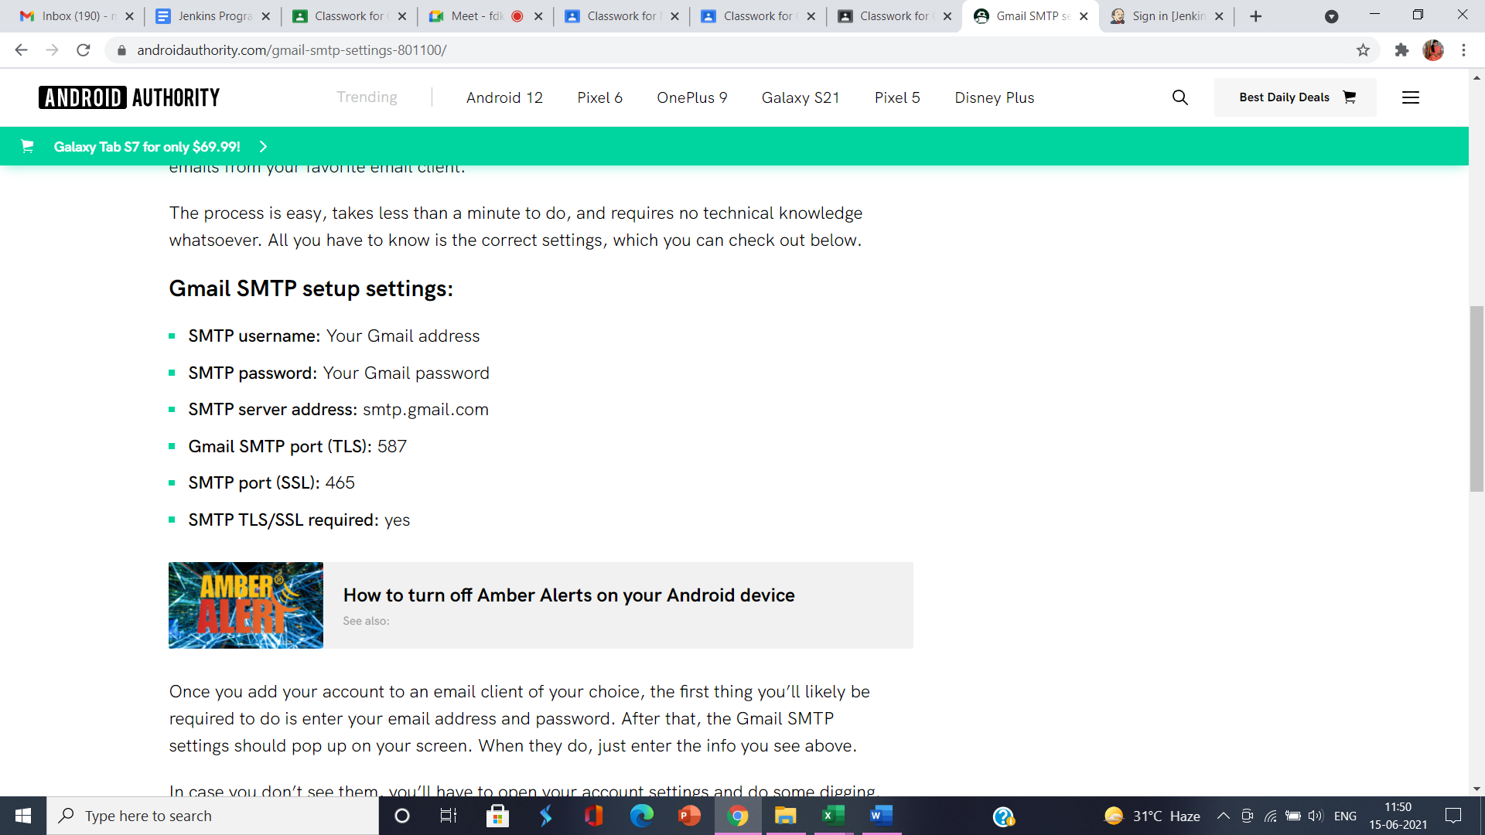

Step 2:Open jenkins select Manage Jenkins option from the Menu

Step 3:Select System Configuration and click on Configure System to set up SMTP settings

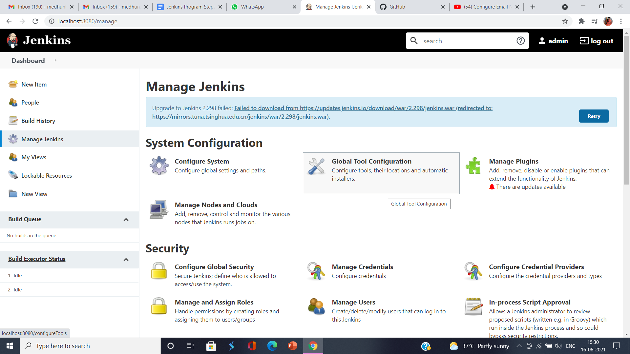

Step 4:Select Extended Email Notification option and add settings

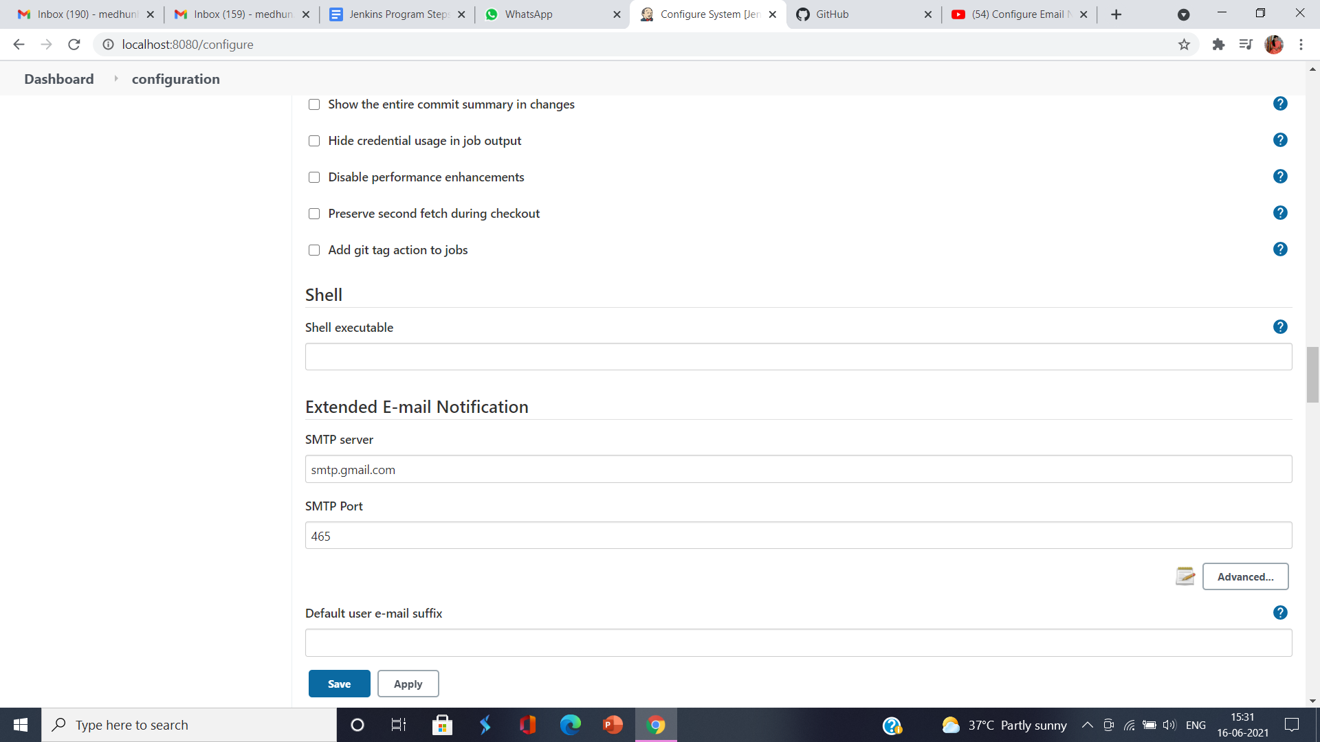

Step 5:Click on advanced option and add settings

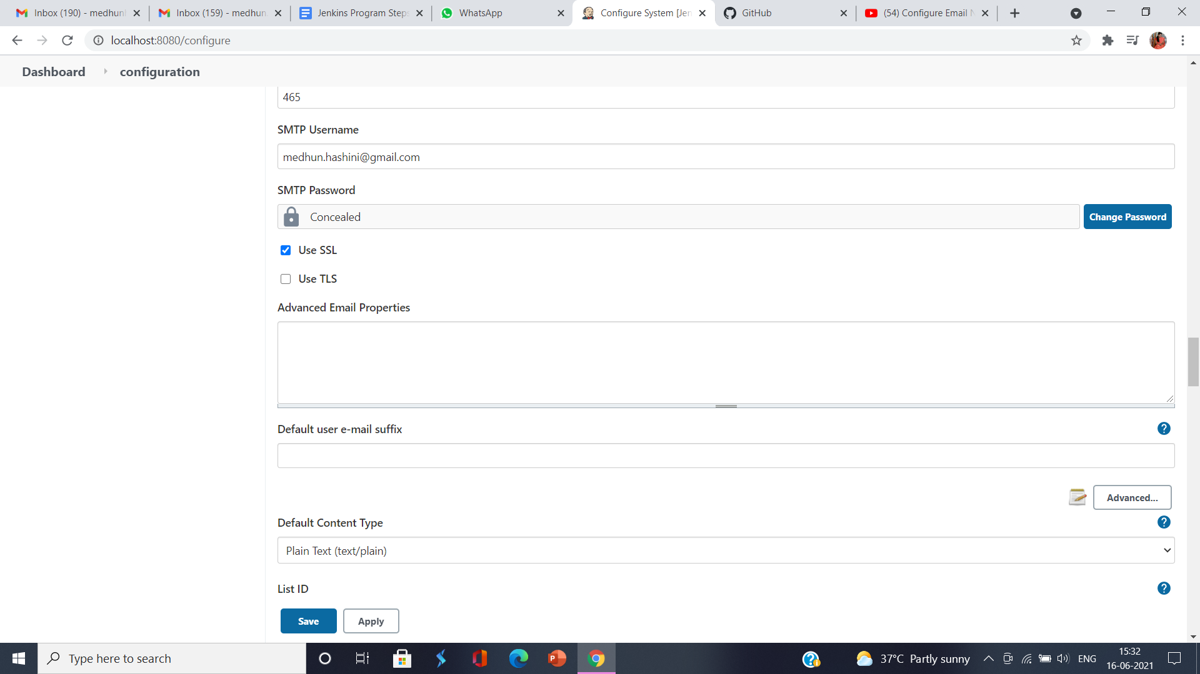

Step 6:Select Email Notifications and add settings

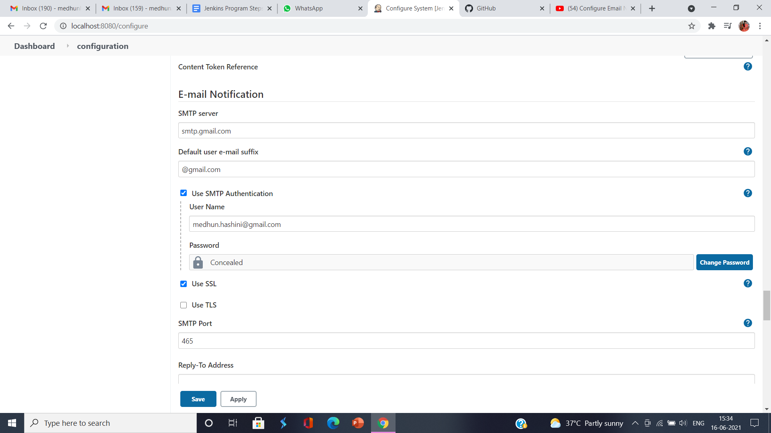

Step 7:Test configurations by sending test mail then click Apply and Save

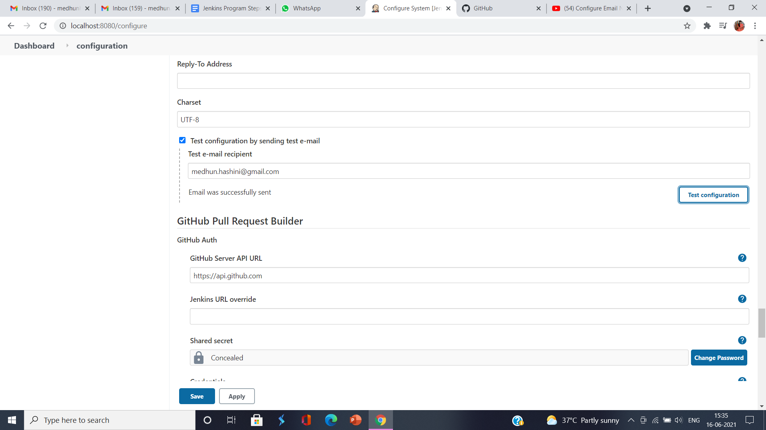

Step 8:Select the job then click configure - select Post Build Action and choose Editable Email Notification

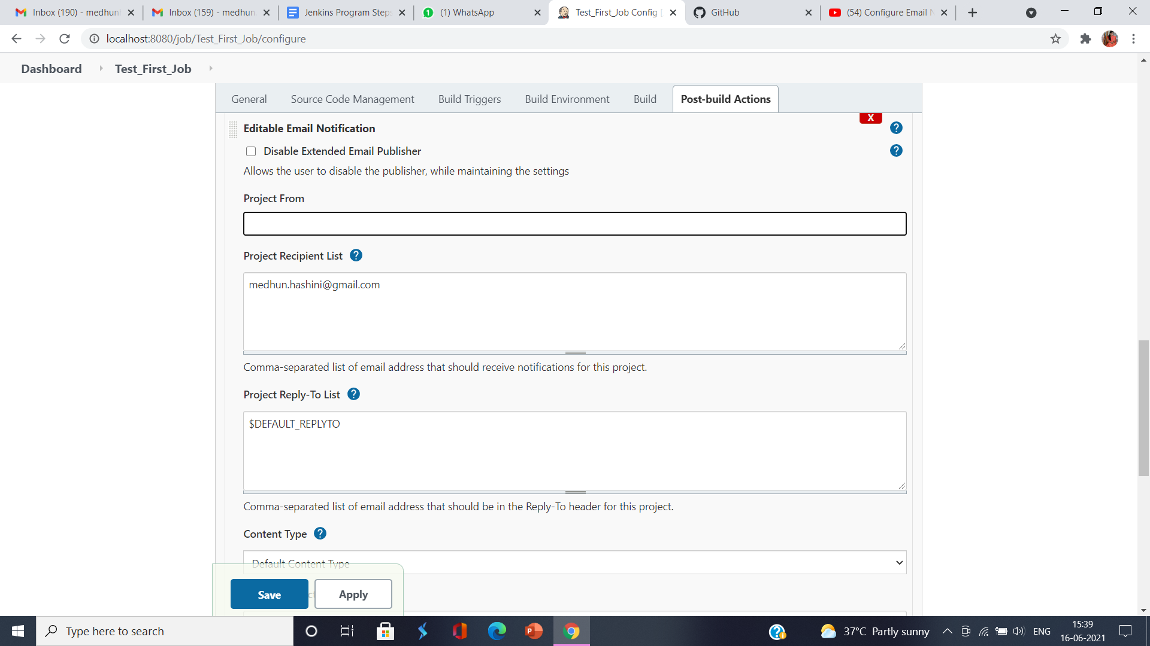

Step 9:Click advanced settings and select Trigger as Always then click apply and save

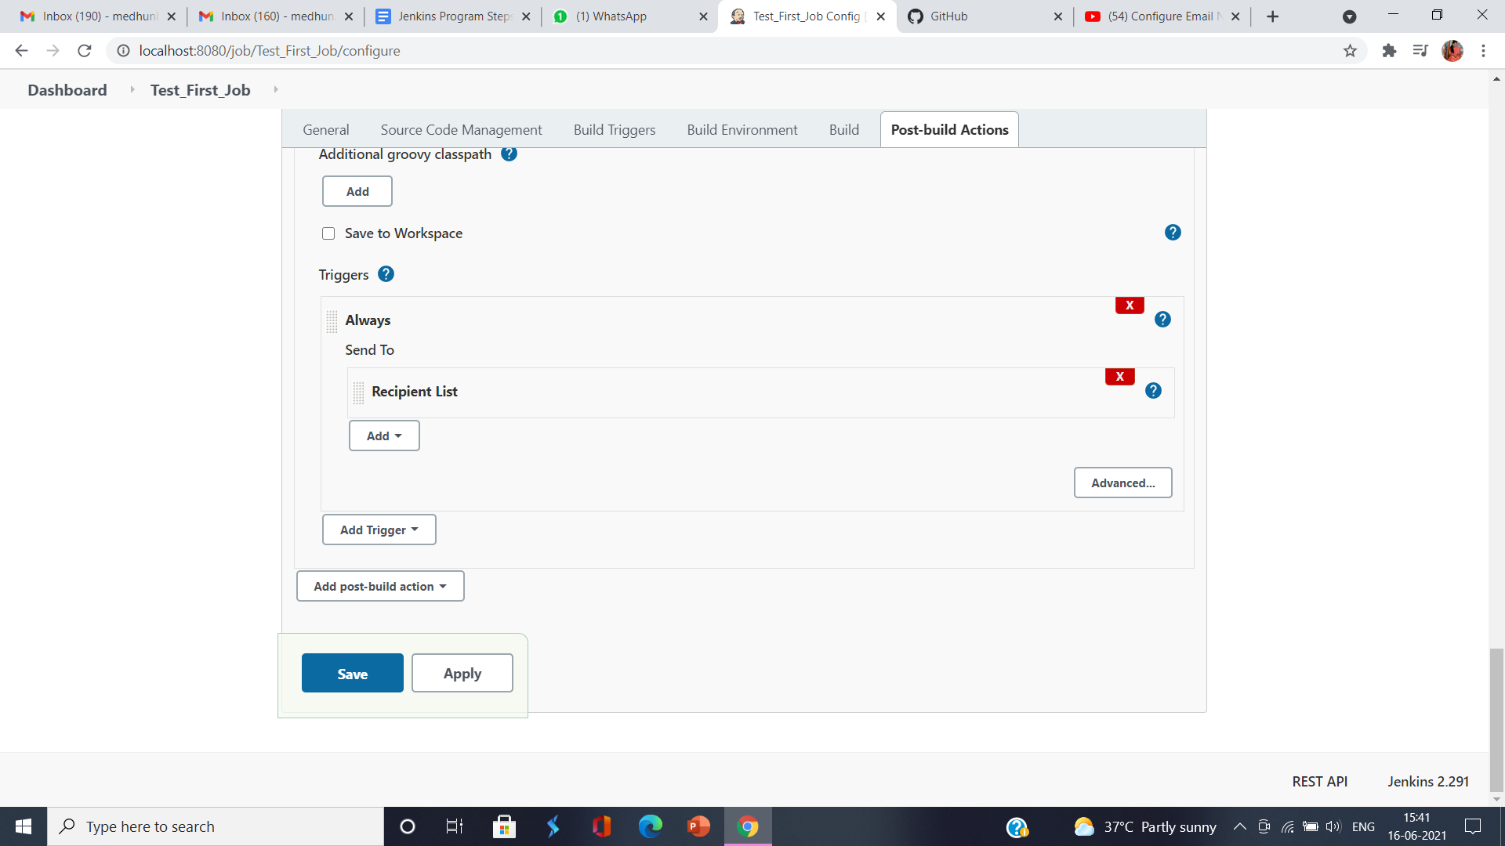

**Note : If test email fails change security settings in gmail**

**Goto my account**

**Select security options- keep less secure apps access settings ON**

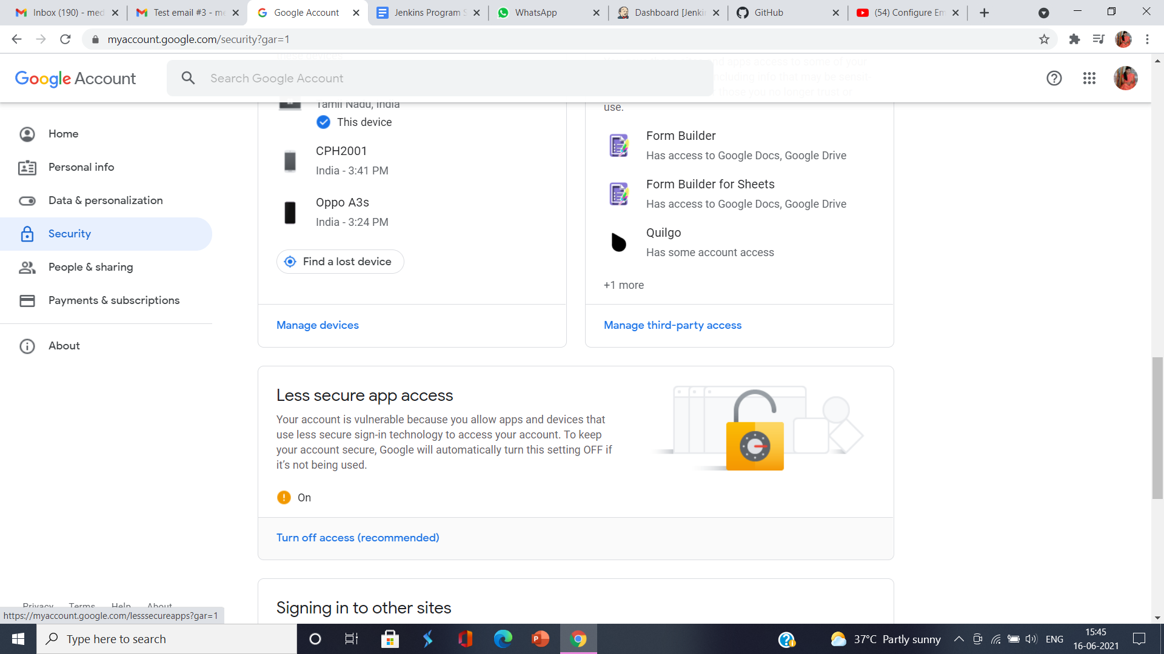

**10.Create and manage users in jenkins using Role-based Authorization Strategy Plugin**

Aim of the Program:

To create and managers users using role-based authorization strategy plugin

Algorithm:

Step 1: Open Jenkins dashboard by visiting <http://localhost:8080/jenkins>

Step 2: Click on 'Manage Jenkins' and select the 'Available' tab.On the filter option, type "role-based" and press Enter.Now, select the plugin and click on 'Install without restart' button.

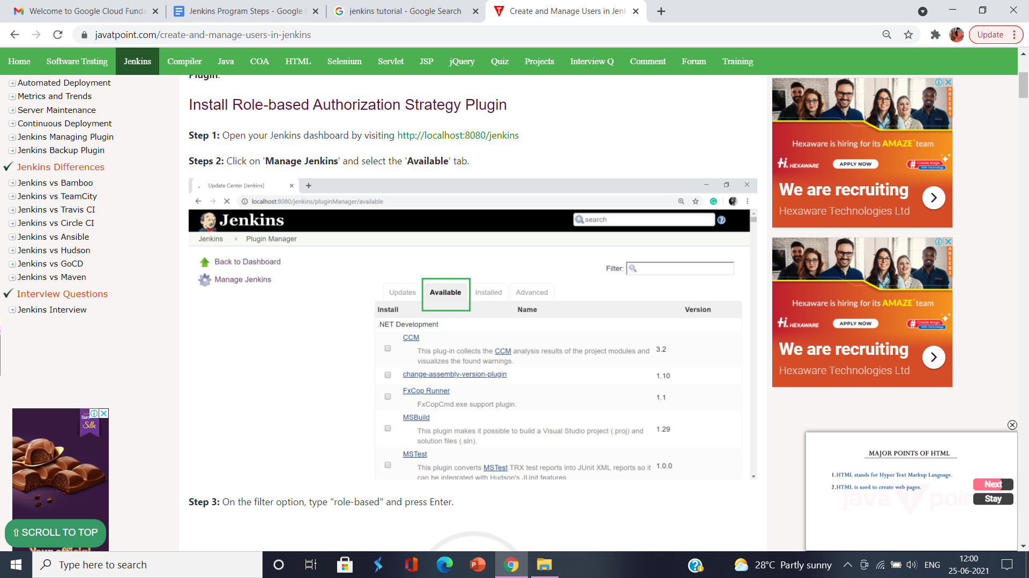

Step 3:After Plugin installation, go to the 'Manage Jenkins' and then click on 'Configure Global Security'.On the Security Realm section, select 'jenkins' own user database'.

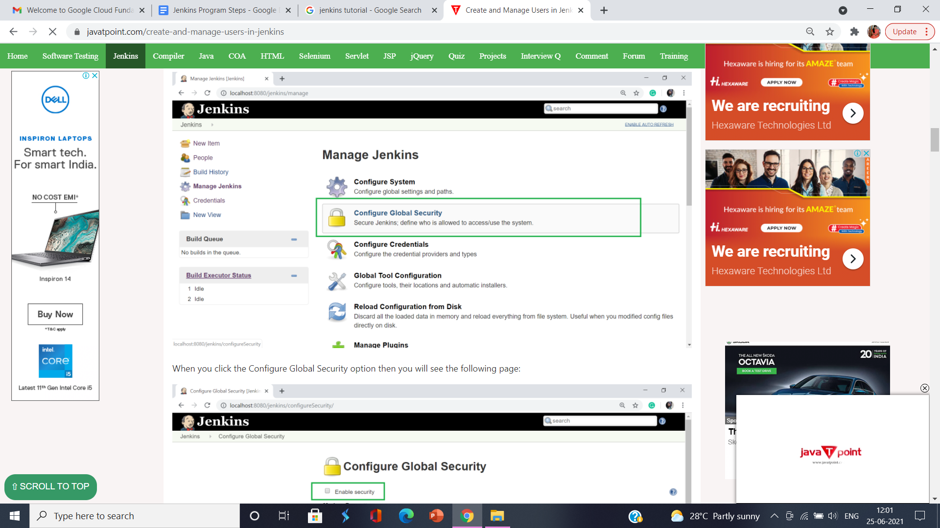

Step 4:On the Authorization section, select 'Role-Based Strategy'.Click on Save.

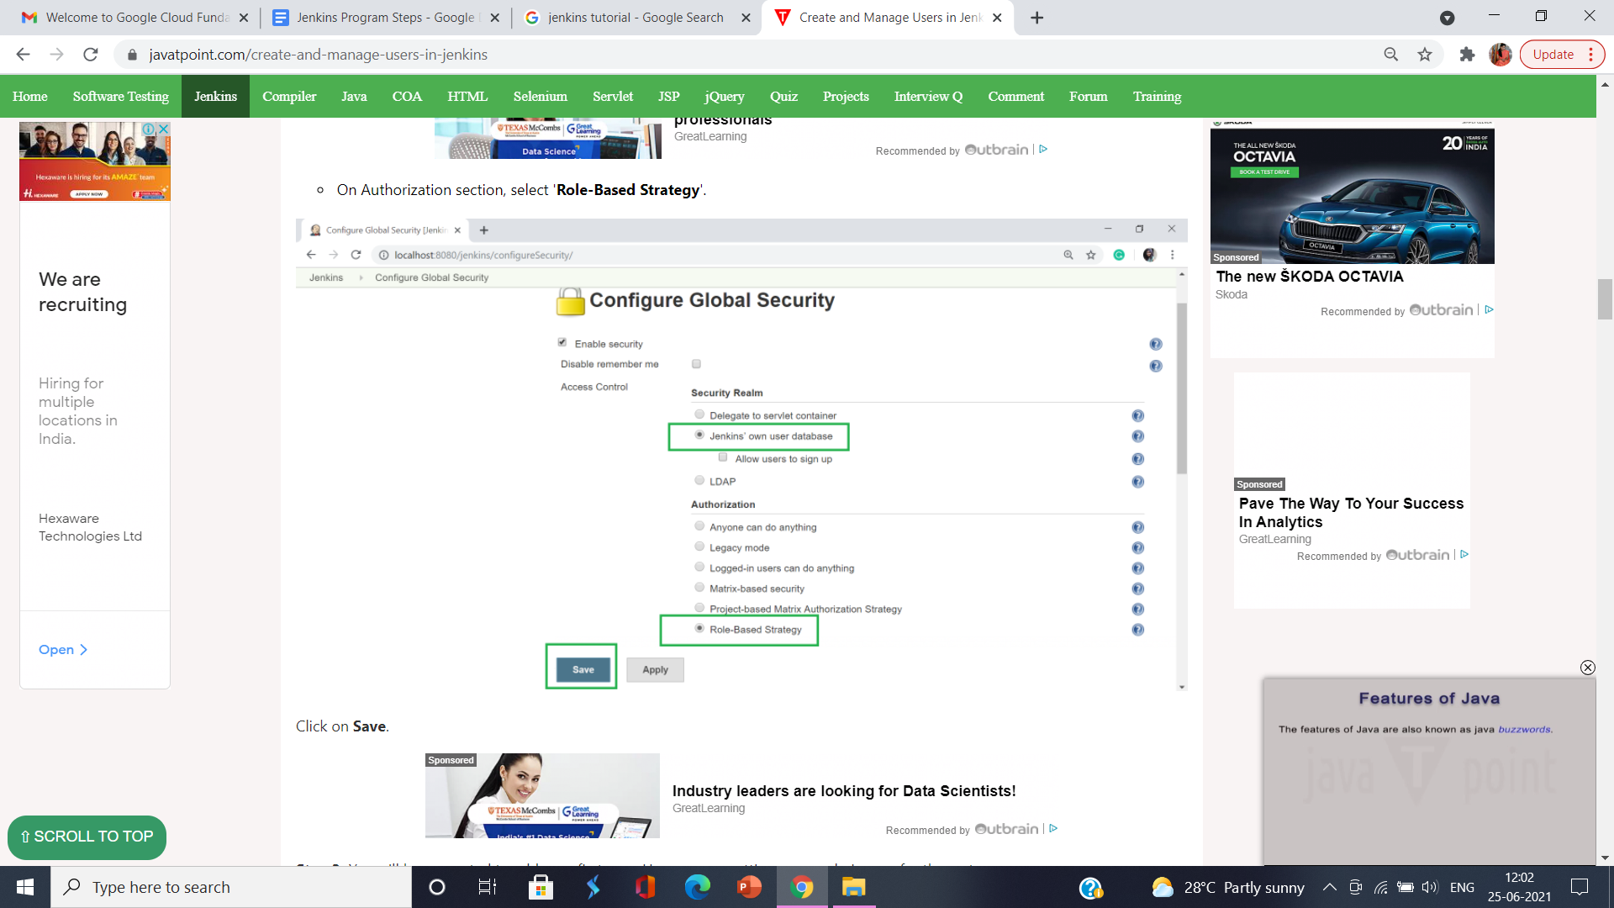

Step 5:Go to manage Jenkins and scroll down, you will see the 'Manage Users' option. Click on this option.To create user click on 'Create User' option on the left hand side of the Manage Users page.

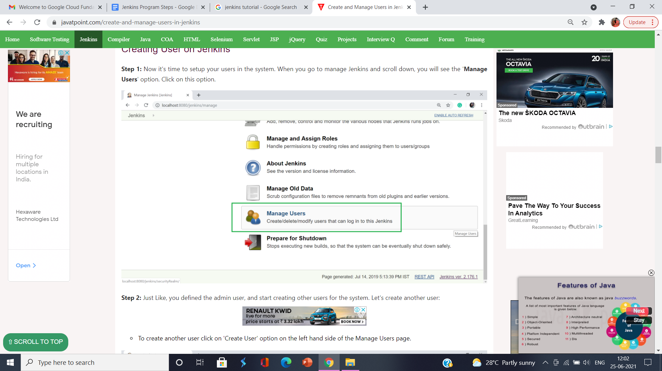

Step 6:Click on Manage Jenkins..Select Manage and Assign Roles.Click on Manage Roles option to add new roles.To create a new role called "developer".

* Type "developer" in the Role to add options.
* Click on Add to create a new role.
* Now, select the appropriate permissions that you want to assign to the developer role.
* Then Click on Save button

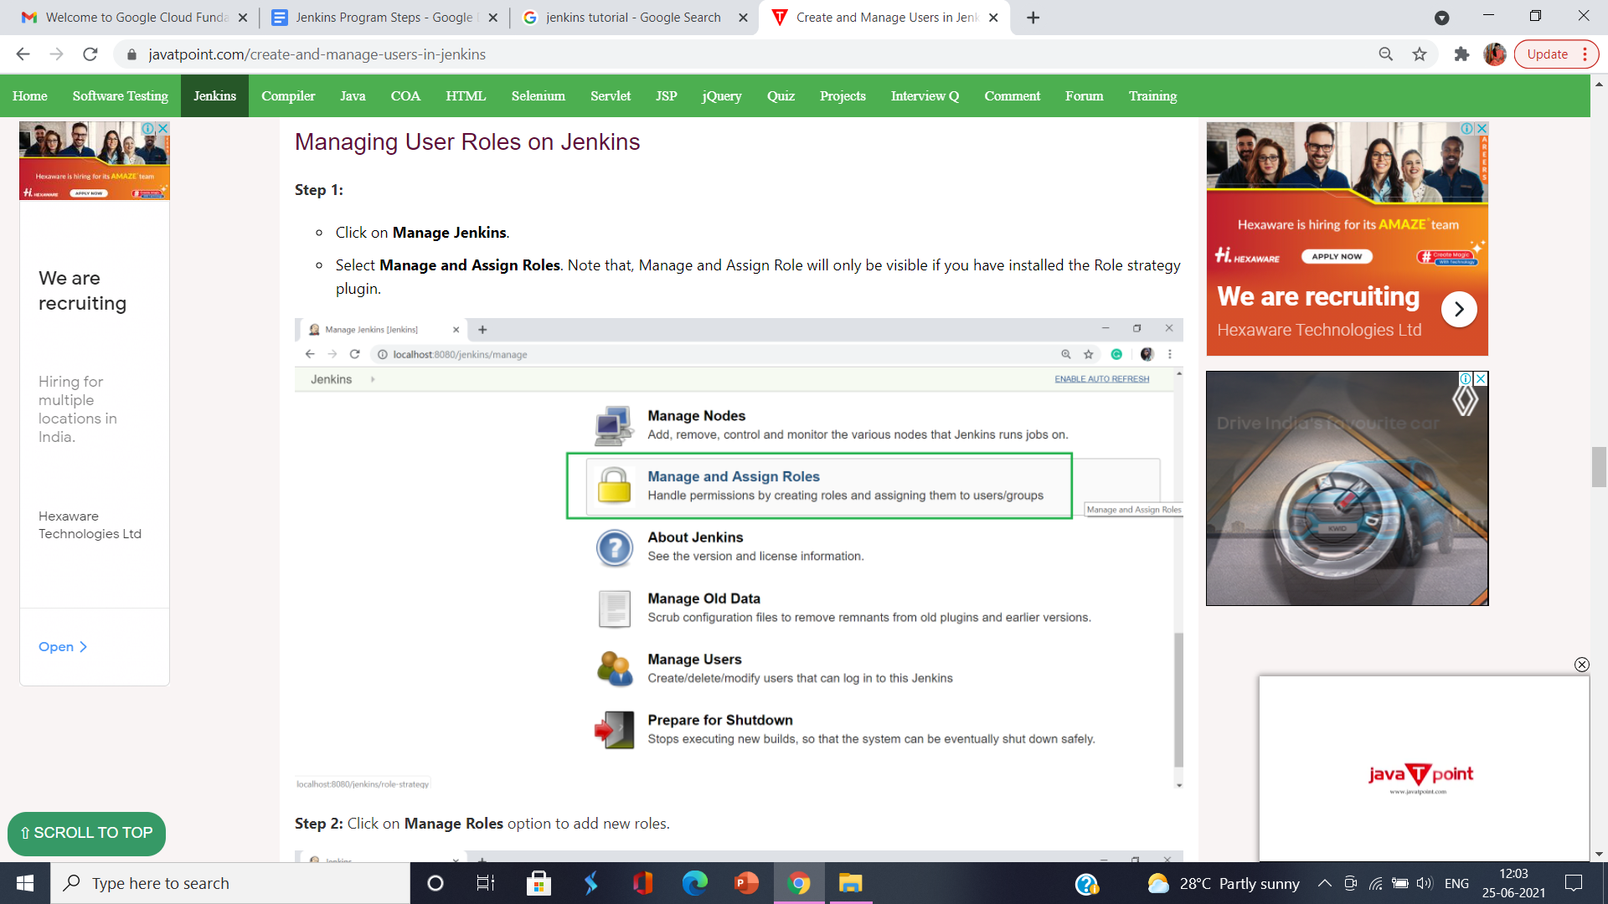

Step 7:You have created roles,now assign them to specific users.

* Click on Manage Jenkins.
* Then select Manage and Assign Roles.
* Click on Assign Roles.

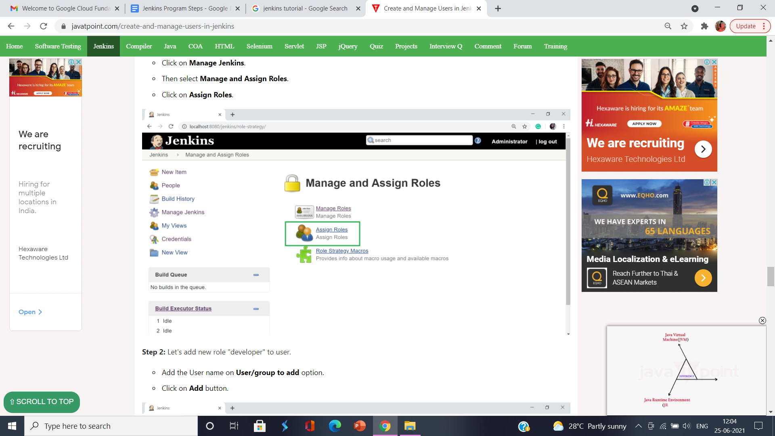

Step 8:Add a new role "developer" to the user.

* Add the User name on User/group to add options.
* Click on the Add button.
* Select "developer" role check box.
* Then click on Save.

